Corner Grocer: Grocery Item Tracker

Krisztofer Lindh
Computer Science Student at SNHU
CS-210 Programming Languages
Prof. Esendemir
February 22, 2026

Introduction
The Corner Grocer item-tracking program is a C++ application that is designed to read a .txt file of grocery store inventory items, count the frequency of each item within the .txt file, and present that data to the user through an interactive menu. The program’s main functionality comes from the GroceryTracker class with private data members for a map called itemFrequency, which pairs each item name with the number of times it appears in the input file. Storing the data as a private member and exposing functionality through public methods ensures that the data is properly encapsulated and protects the integrity of the data.
When the program is launched, it calls the loadFile() function, which opens CS210_Project_Three_Input_File.txt using an ifstream and reads each word on the file, one at a time, via a while loop. Each word is converted to lowercase via a helper function, toLowerCase(), before being incremented in the map. Normalizing the data to read in lowercase ensures that “Apples,” “apples,” and “APpLeS” are treated as the same item. Immediately after loading the file, writeBackupFile() runs automatically and writes every item frequency combination to a file called frequency.dat without any user interaction.

Upon completion of the file reading and backup file creation functions of the program, the program then enters a menu loop offering four options. Option one prompts the user for an item name, calls the getFrequency() function, and prints the count of that item’s frequency:
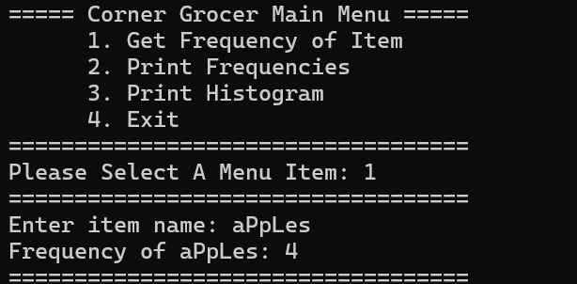

Option two calls the printFrequencies() function, which iterates through the map and displays each item with its corresponding frequency count:
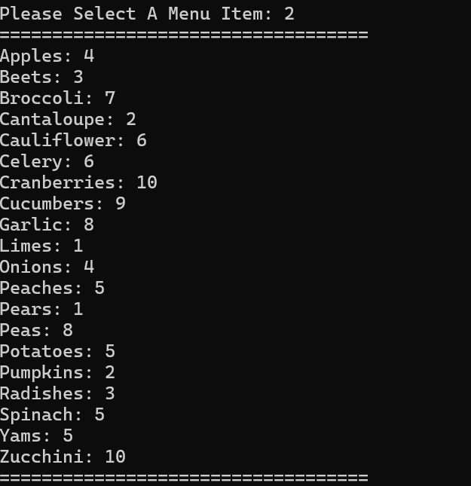
Option three calls printHistogram(), which uses std::setw() for right-aligned item names and std::string(count, ‘*’) to produce a formatted row of asterisks for each item:
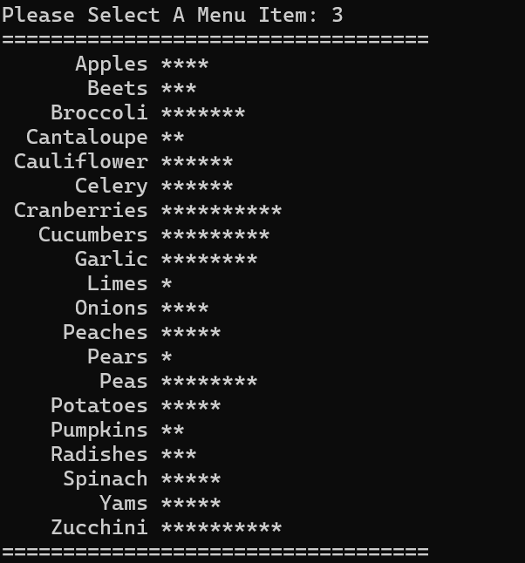
Option four exits the program. Input validation using cin.fail() and cin.clear() with cin.ignore() prevents non-numeric input from causing an infinite loop.
Several design decisions shaped how I programmed this. For example: The std::map list was chosen because it natively associates string keys with integer values and automatically sorts entries alphabetically, which produces a cleaner output without the need for additional sorting logic. Function definitions are placed outside the class body using the GroceryTracker:: scope operator, following the standard header-and-implementation separation pattern.

